Input Sheet Improvements needed –
- Current RFP Stage Column to be added.
- Price Alignment is not taken into account for output? As blank field did not generate any reaction. Should mandatorily give a warning to enter the Price or atleast three attributes – (a) Client Budget Info not available. (b) On par with Client Budget (c) Above Client Budget with Rationale/Caveats (d) Above Client Budget
Output Improvements needed – Since we are going with the Win-Loss prediction, the Probability is not inline with the weekly reports. It should be High, High Medium, Medium, Medium Low, Low.

Tests Results:
- Output File not downloadable
- Input 1 Sheet – Client Relationship Field – Blank. Result - Shows Lost.
Modification Required – Show Exception Error – “Field empty. Enter Input”
- Input 1 Sheet – Client Relationship Field – Low. Result – Shows Lost.
Modification Required – Need not necessarily be lost. Depends on the RFP stage. If we have cleared Defence, the probability should be High Medium or High
- Input 2 Sheet – Client Relationship Field – Positive. Result – Shows Won.
Modification Required – Need not necessarily be Won. Should showcase Win probability as per the stage.
- Input 3 Sheet – Client Impression Field – Blank. Result – No Impact.
Modification Required – Client partner to provide update for the stage basis the Win Probability to higher.
- Input 4 Sheet – Account Engagement Field – Blank. Result – No Impact.
Modification Required – Client partner to provide update for the initially / stage basis the Win Probability to higher.
- Input 5 Sheet – Primary L1 n Primary L2 Field – Blank. Result – No Impact.
What is the logic of having these 2 fields for prediction. At the moment all the predictions are happening only on the basis of “Client Relationship” field

Test Set Result Snapshots

- and 3.
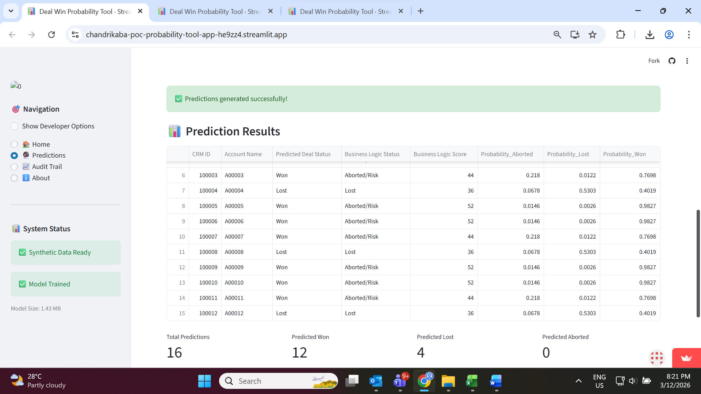

4.
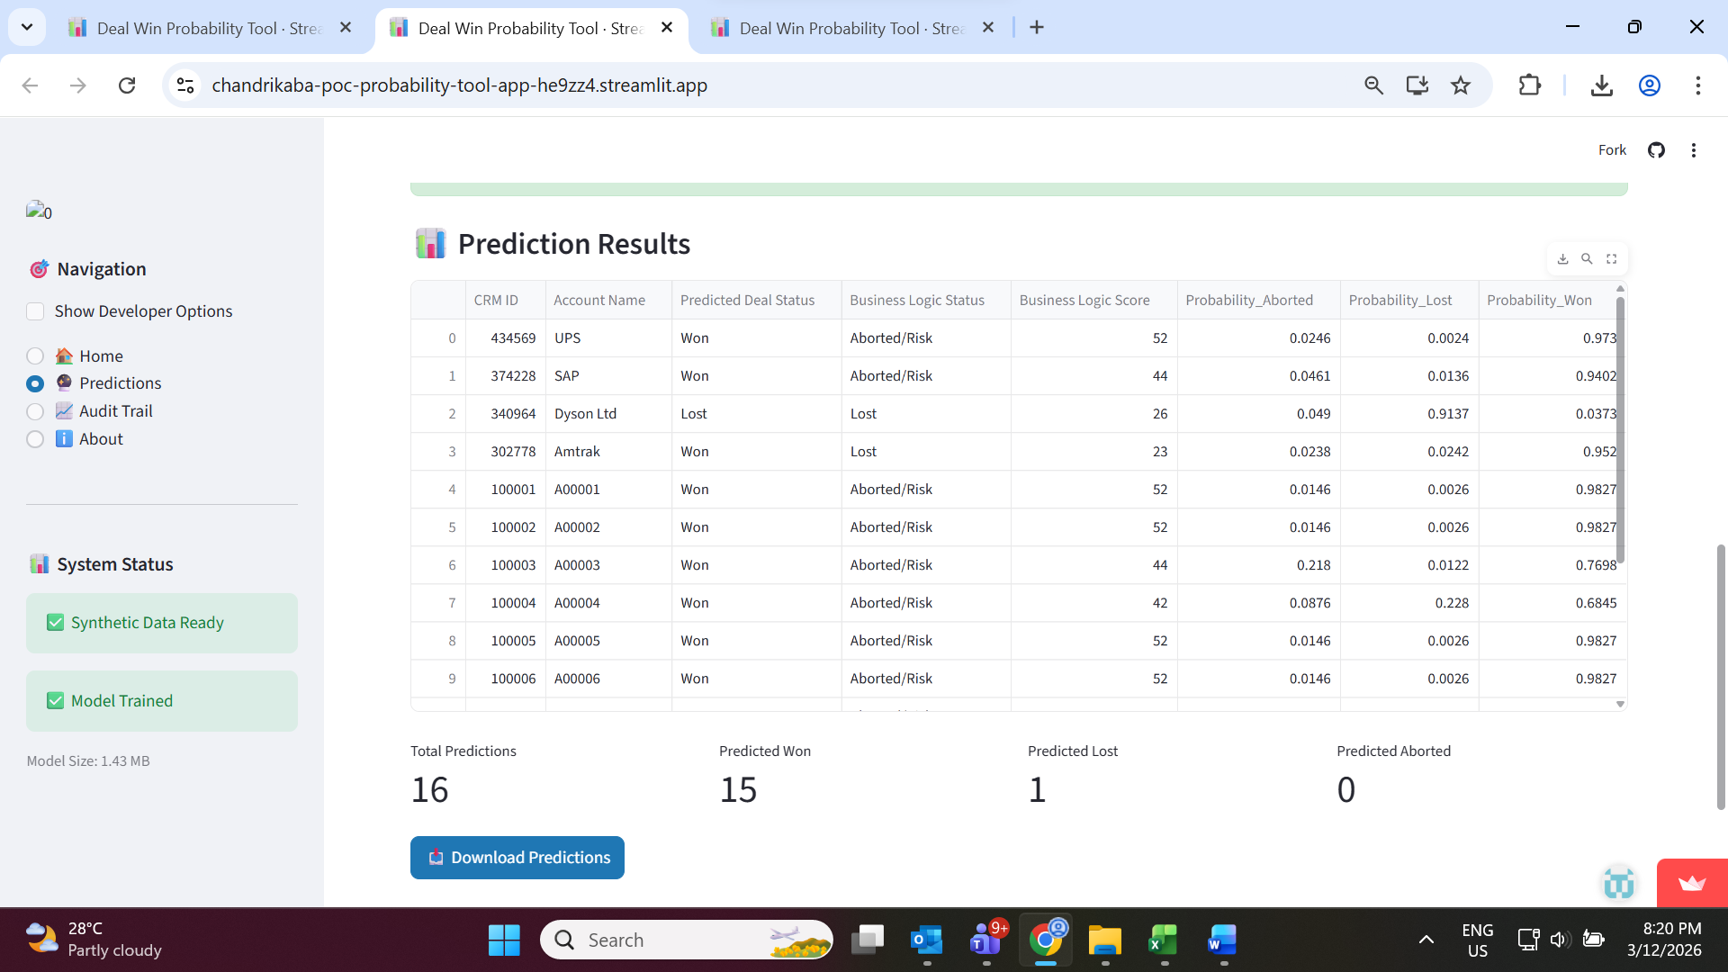

5.
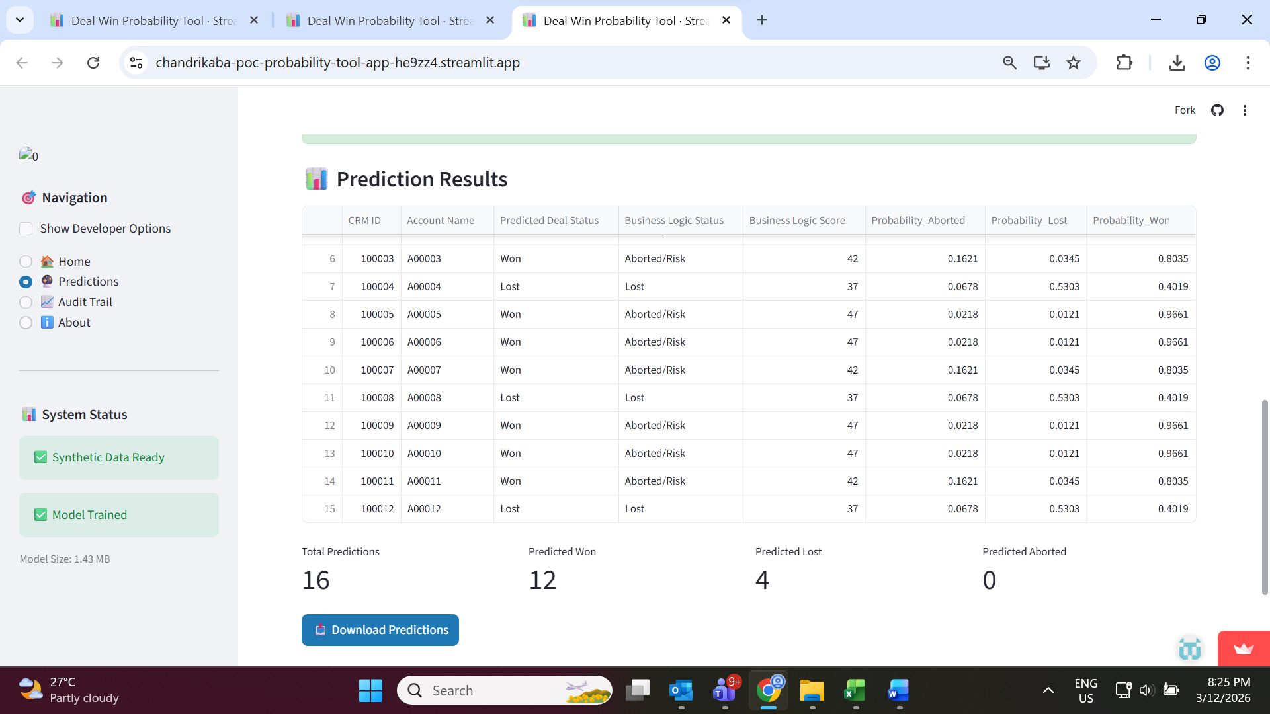
6.
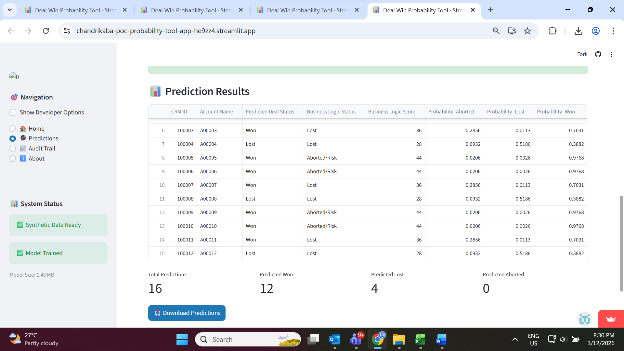

7.
